**Ideation Phase**

**Brainstorm&Idea Prioritization Template**

|  |  |
| --- | --- |
| Date | 9 November 2022 |
| Team Id | PNT2022TMID52122 |
| Project Name | Virtual Eye-Life Guard For Swimming Pools To Detect Active Drowning |
| Maximum Mark | 4Mark |

Brain Storming 1

STEP-1

Team Gathering collaboration and select the problem statement

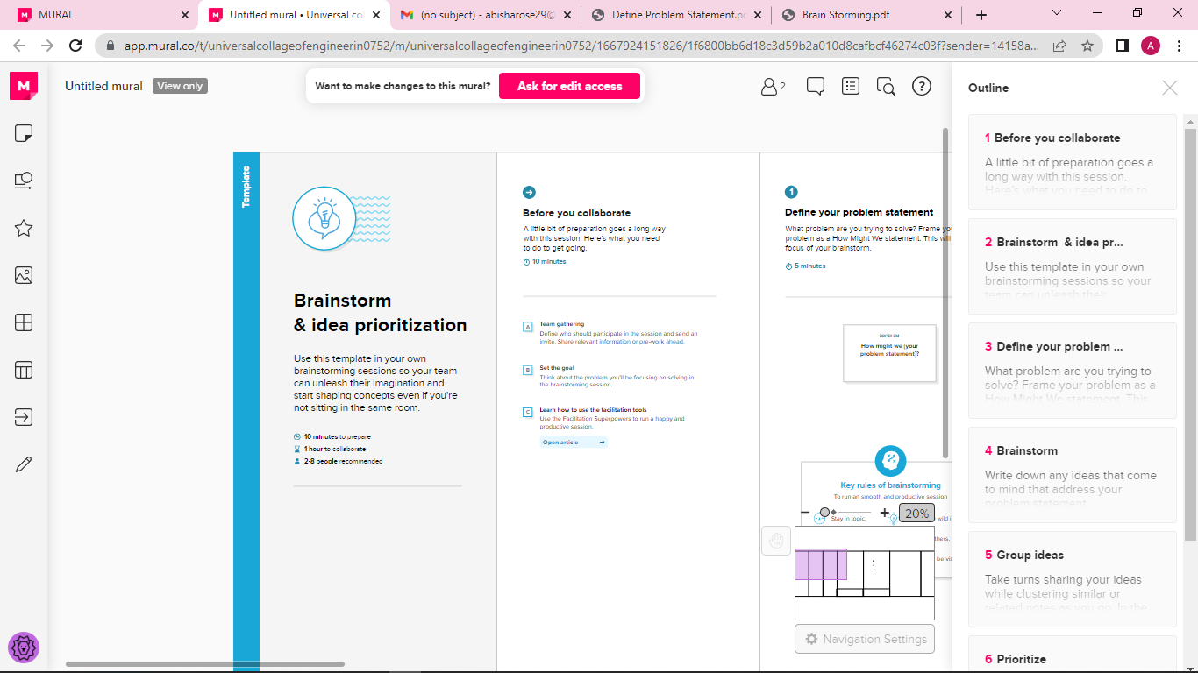

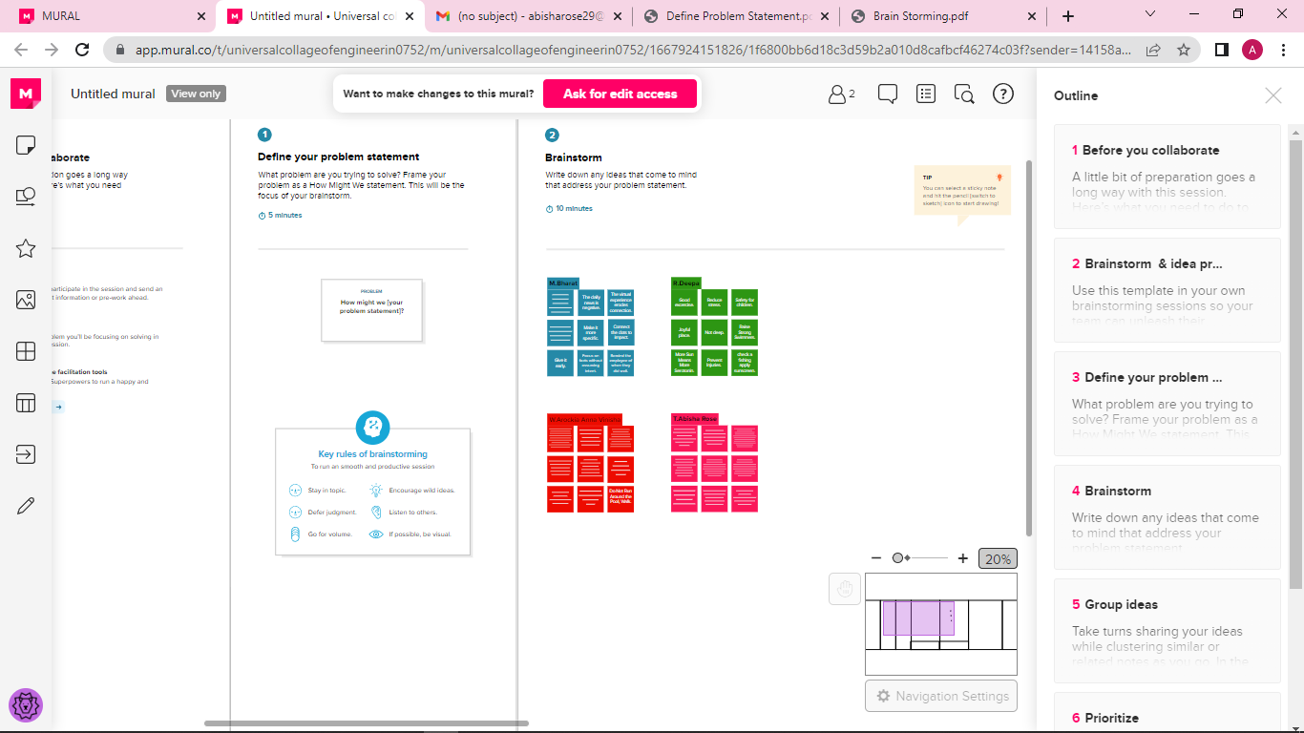

STEP-2 Brain Storm,Idea Listening and Grouping

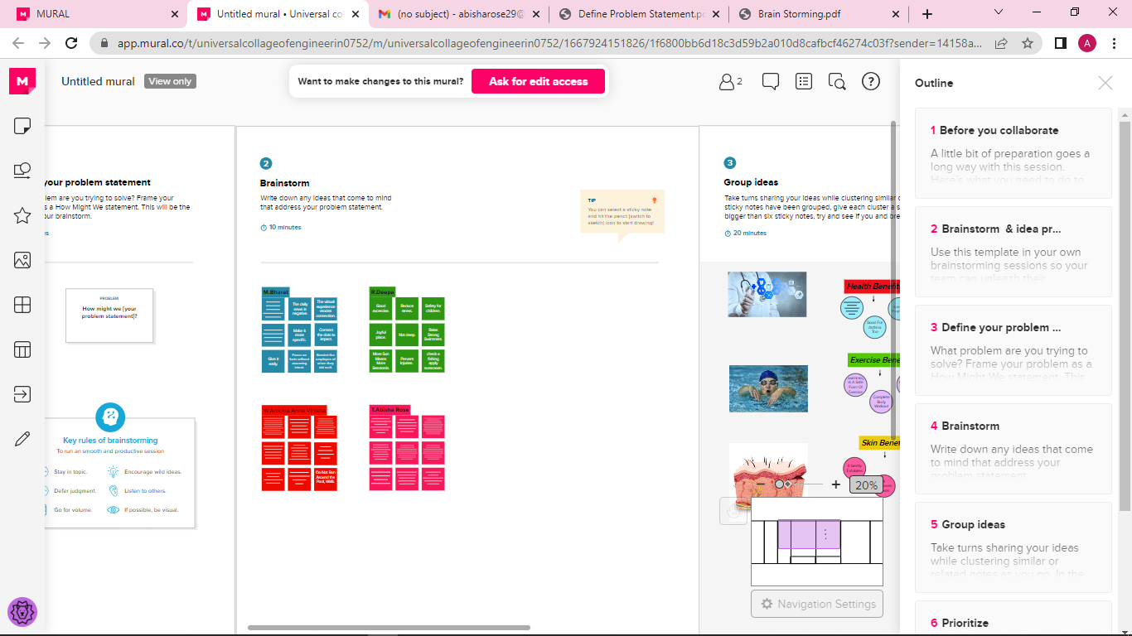

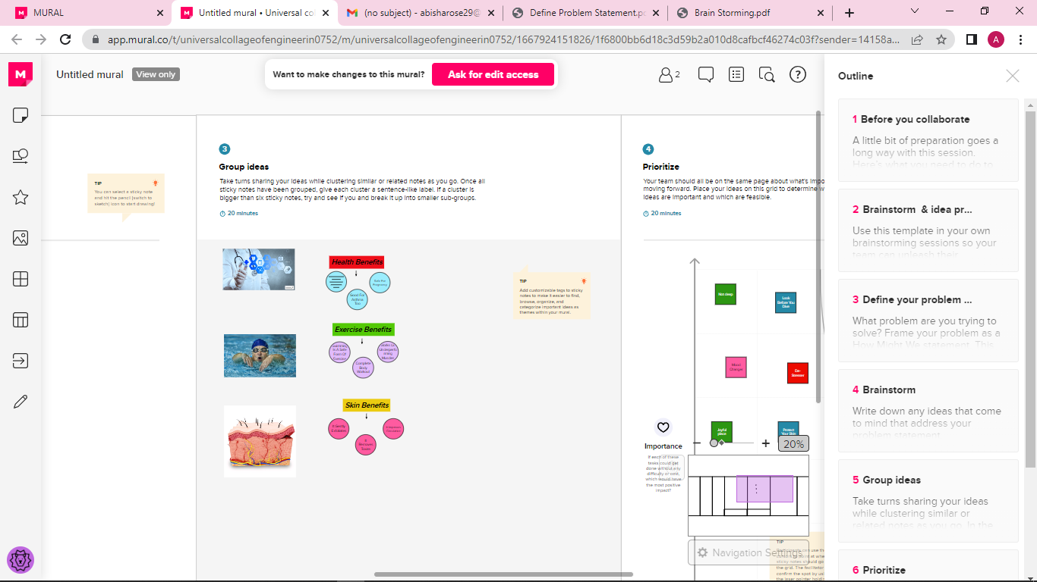

STEP-3

Prioritization

